IAutoDrawSim
Process Simulation Tutorial
Advanced Professional Edition (for Windows) — Version 3.8.5
A hands-on guide to process simulation modeling, industry cases, and component reuse

Table of Contents
Table of contents: open the document and update this field (Word: F9 / WPS: right-click → Update Field).

Preface
This manual introduces the process simulation capabilities of IAutoDrawSim through a series of practical, real-world examples. It is organized into four chapters: a conceptual introduction to process simulation (Chapter 1), the core simulation features of the software (Chapter 2), five step-by-step case studies (Chapter 3), and component encapsulation techniques for building reusable libraries (Chapter 4).
The examples in this book are of medium complexity (typically 10–100 nodes). The underlying principles scale directly to larger systems; models with thousands of nodes can be built and run with the same workflow.
This manual serves as both an operating reference for IAutoDrawSim and an advanced supplement to the basic tutorial. It is suitable for engineers, analysts, instructors, and students who want to turn static process diagrams into executable, quantifiable, and optimizable simulation models.
Note: The interface captures shown in this manual are from the current build of IAutoDrawSim. In some screenshots the interface is displayed in Chinese; the functional labels are explained in the accompanying English captions and annotations.
Note on the case data: the flow rates, compositions, kinetic constants and concentrations used in the Chapter 3 cases are internally consistent worked examples chosen to make the arithmetic easy to follow. They are not design data. Before using any of these models for a real study, replace the parameters with values taken from property data, plant measurements or a validated design basis.

Chapter 1 Process Simulation: A New Way of Thinking
When we face a complex system—a factory production line, a cross-department approval workflow, or the lifecycle of a software project—our instinct is to draw a flow diagram. A diagram helps us clarify sequence and responsibility. But a static drawing can only answer "what it should look like." When we ask "what happens if demand doubles?" "which step is the real bottleneck?" or "is option A or B better?" the drawing falls silent.
This chapter introduces a more powerful way of thinking: process simulation. Simulation is not merely a software feature; it is a disciplined approach to abstracting, quantifying, and dynamically analyzing complex systems. We trace its conceptual roots, examine the limits of traditional methods, and explain how a graphical process simulator such as IAutoDrawSim provides a new paradigm for insight.

1.1 What Is Process Simulation?
A process is a sequence of interconnected activities that transforms inputs into valuable outputs. Simulation is the practice of building a matching, executable, dynamic model of that system on a computer, in order to understand, analyze, or improve it.

1.1.1 From Static Flow Diagrams to Dynamic Simulation
Think of a city transit map. A static paper map (much like a diagram drawn in Visio) clearly shows station locations and connections, but it cannot tell you which line will be congested at rush hour, or how opening a new station would redistribute passenger flow. Process simulation injects time, data, and logic into the static diagram, turning it into a "living" digital sandbox that can be run and experimented with.
The essential difference:
- Static flow diagram: describes the intended state of the system (As-Is or To-Be). It is a document; it answers "what is" (What).
- Dynamic process simulation: reproduces the dynamic behavior of the system. It is an experimental tool; it answers "what if" (What-If).
Simulation is characterized by three core features: dynamics (advancing by time steps or discrete events), quantification (every activity and decision can be linked to concrete data such as time, cost, or quantity), and experimentality (allowing safe, low-cost testing of different scenarios and policies).

1.1.2 Core Elements of a Simulation Model
Building an effective simulation model—regardless of the tool—requires an understanding of five fundamental building blocks:
- Entity: an object that flows through the process. It can be physical (a part being machined, a patient) or informational (a purchase order, an approval request).
- Activity: a task that processes entities and consumes time (machining, reviewing, transporting).
- Resource: the people, equipment, or space needed to perform an activity. Resources are usually limited, so entities may wait for a resource to free up, forming queues.
- Queue: the temporary holding area or list where entities wait for the next activity. Queue length and waiting time are key measures of system efficiency.
- Control logic: the rules that govern how entities move between activities, including branching decisions (e.g., "if inspection passes, route to packaging; otherwise rework"), priority rules, and routing choices.
A simple process simulation is the movement of entities through activities, queues, and resources under the control logic.

1.1.3 The Ultimate Purpose: Insight, Prediction, and Optimization
Why build such a dynamic model? Its value reduces to three points:
- Insight: reveal hidden problems—bottlenecks, idle resources, excessive queues—before a system is implemented or changed. Simulation is the "X-ray machine" of a system.
- Prediction: evaluate how alternative designs, operating strategies, or external changes affect overall performance (cycle time, capacity, cost).
- Optimization: on the basis of prediction, run repeated experiments and comparisons to find a better configuration and drive continuous improvement.

1.2 The Evolution of Process Simulation

1.2.1 Early Era: Pure Mathematics and Custom Code (1950s–1980s)
In the early days of computing, simulation relied entirely on rigorous mathematical theory and programming. Researchers used differential equations to describe continuous systems (e.g., chemical reactions) or discrete-event simulation theory to build queuing models. Everything had to be coded from scratch (commonly in Fortran or Simula). This phase was powerful but niche, accessible only to scientists and senior engineers.

1.2.2 Development: Specialized Simulation Software (1990s–2010s)
With the growth of graphical user interfaces, specialized packages such as Arena, FlexSim, AnyLogic, and ExtendSim appeared. They provided visual modeling environments where users dragged predefined modules (arrival, processing, departure) to build models, greatly lowering the barrier to entry. However, these tools are often highly optimized for particular domains (manufacturing, logistics, healthcare); their built-in modules encapsulate domain logic, and non-standard or highly customized business rules can still require scripting and a nontrivial learning curve.

1.2.3 Today: Convergence and Accessibility (2010s–present)
Cloud computing and low-code/no-code concepts have pushed simulation toward a broader audience, with trends toward cloud deployment, collaboration, and business-system integration. Yet a clear gap remains: between general-purpose programming (extremely flexible but hard to learn) and specialized simulation software (easy to start but inflexible), there has been a lack of a tool that balances intuitiveness, flexibility, accessibility, and depth. Many analysts are still forced to combine "Visio drawing + Excel calculation + human imagination." This gap is the soil in which IAutoDrawSim was born.

1.3 Challenges of Traditional Methods

1.3.1 The "Visio + Excel" Trap
- Static by nature: the diagram is "dead." Any small logic change may require redrawing and manually updating many linked Excel cells—tedious and error-prone. The model cannot run; it can only be imagined.
- Data silos: process logic (in Visio) and calculation data (in Excel) are physically separated. The link between them is fragile; when versions diverge, the model immediately loses fidelity, impeding maintenance and iteration.
- Collaboration pain: files are scattered across machines with version chaos. The business logic and calculation assumptions behind a process are buried in complex Excel formulas or VBA code, hard for team members to review, understand, and pass on.

1.3.2 Limits of Specialized Simulation Software
- High barrier: users must first learn simulation theory and the software's modeling framework, which is unfriendly to non-technical business staff.
- Limited flexibility: the predefined module libraries serve classic scenarios. For unique, cross-domain, innovative processes, modeling can become awkward and circuitous.
- Cost and integration: licenses are expensive and deployment complex. Models often exist as isolated "analysis islands," making data exchange and integration with operating business systems (OA, ERP, CRM) inconvenient.

1.3.3 The Profile of an Ideal Tool
- As intuitive as drawing: modeling should follow natural thinking—drag and connect to build the skeleton.
- As flexible as Excel: easily embed business logic and mathematical calculations.
- As dynamic as specialized simulation software: a full simulation engine supporting time advancement, event scheduling, and randomness.
- As accessible as office software: a gentle learning curve, controlled cost, quick startup for individuals and teams.
- As integrable as a development platform: connect external data sources and expose APIs to fit into a broader digital ecosystem.

1.4 IAutoDrawSim: A New Graphical Simulation Paradigm
IAutoDrawSim was born from these insights. It is more than software—it represents a new, unified graphical process simulation paradigm.

1.4.1 Core Philosophy: What You See Is What You Simulate
The core idea: every graphical element you place on the canvas is no longer merely a visual symbol, but a "living" object that carries state, data, and behavior. The canvas itself is an executable modeling and experimentation environment. The graphical network you see is the business system you simulate.

1.4.2 Paradigm Revolution: Three Key Integrations
- Unified environment for design, calculation, and simulation: drawing the process, defining node attributes, writing processing logic (via Func scripts), setting simulation parameters, running the simulation, and viewing dynamic charts all happen on the same canvas and in the same interface—no more switching between tools.
- Logic deeply embedded in graphics: each node or connector can be associated with a JavaScript script. Any complex, non-standard business rule—from simple condition checks to calling external algorithm APIs—can be injected directly into a graphical element, giving models unlimited flexibility.
- Hierarchical, recursive system modeling: through "subsystems," a complex node can internally contain a complete process model. This matches the systems-engineering philosophy of "top-down design, bottom-up modeling," making large, multi-level system models clear and orderly.

1.4.3 Positioning: Filling the Gap
To clarify IAutoDrawSim's unique positioning, we compare it against a broader tool spectrum. At one end are highly specialized but domain-limited heavy packages; at the other are generic, simulation-less lightweight tools.
1. Aspen Plus, HYSYS, PRO/II — professional chemical process simulators
- Position: domain-specific "engineering heavyweights," designed for rigorous thermodynamics, kinetics, and material/energy balances in oil, chemical, and pharmaceutical process industries.
- Strengths: accuracy and authority (deep physicochemical principles and large property databases, industrially validated); model depth (many built-in unit operations such as distillation columns and reactors).
- Limits: high barrier and cost (deep domain knowledge, expensive enterprise-grade licensing); domain closure (their power is confined to process industries and is hard to apply to business management or logistics).
2. Visio + Excel
- Position: general-purpose static drawing and data analysis; the most common combination for describing processes and doing basic calculation.
- Strengths: high accessibility and ease of use; flexibility in principle (formulas and VBA can implement almost any calculation).
- Limits: static and fragmented (diagrams cannot run; logic changes must be manually synced with graphics and data); no simulation engine (no dynamic reasoning, time stepping, or discrete-event scheduling).
3. Python / MATLAB — general-purpose programming languages
- Position: the "universal tool" with absolute control.
- Strengths: unlimited flexibility; a rich ecosystem of scientific computing, data analysis, and machine learning libraries.
- Limits: high technical barrier (requires skilled programming; modeling is abstract and difficult to debug); "reinventing the wheel" (even simple process logic requires substantial foundational code).
4. IAutoDrawSim — graphical process simulation platform
- Position: a "systems-thinking canvas" that fills the gap, providing an intuitive, flexible, and integrated professional platform for non-strict-mechanism, cross-domain system simulation.
- Strengths: unified intuitiveness and efficiency (graphical programming; drag nodes and connectors to build the process skeleton); depth and flexibility balanced (Func scripts embedded in every graphical element); dynamic reasoning (built-in simulation engine turns the drawn diagram into a runnable, experimental digital sandbox supporting what-if analysis); broad applicability (not bound to one industry; applicable to business processes, production logistics, system dynamics, research, and teaching).
- Limits: not intended for rigorous mechanism simulation (cannot replace Aspen-class tools for property-heavy, strict-thermodynamics chemical process design); requires basic logical thinking.
Summary: IAutoDrawSim does not aim to replace the "specialized heavyweights" or the "general office suites" at either end of the spectrum. It precisely fills a key market gap: a "just right" solution for complex system analysis that exceeds Visio+Excel yet does not require professional simulation software or programming from scratch. It lowers the modeling threshold from "writing code" to "describing logic," letting engineers, analysts, and managers quickly turn mental models into interactive, calculable, optimizable dynamic models that drive simulation-based decisions and innovation.

1.4.4 Application Prospects: From Industry to Commerce
IAutoDrawSim's graphical process simulation paradigm is applicable across industries. Its core application domains fall into three directions.
1. Industry and manufacturing: from physical processes to digital twins
- Process industries (chemical, pharmaceutical, water treatment): simulate reaction paths, material/energy balances, ionic concentration changes, pipe networks, and supply chains. Embed chemical-reaction kinetic equations via Func scripts to optimize process parameters.
- Discrete manufacturing (automotive, electronics, equipment): simulate production lines, analyze equipment utilization and takt time, optimize scheduling, and model logistics and warehousing.
- Systems engineering and product R&D: build V-model development processes, simulate test and verification flows, analyze reliability and failure propagation.
2. Business and services: from blueprints to executable decision models
- Business process management and optimization: simulate end-to-end order-to-cash, procure-to-pay, and customer-service flows; analyze cycle time and cost; test improvement scenarios.
- Logistics and supply chain: design distribution networks, simulate inventory policies, analyze demand fluctuations, and evaluate site selection.
- Financial services and risk: simulate credit approval, anti-fraud rule engines, portfolio analysis, or market-risk propagation.
3. Research, education, and public service: from abstract theory to interactive sandboxes
- Scientific research and engineering computation: system dynamics, ecosystem analysis, epidemic spread models, and physics simulation.
- Teaching and training: turn abstract management theory (e.g., the beer game), economic principles, or physics laws into interactive teaching simulators.
- Public administration and smart cities: simulate urban traffic, emergency evacuation, and municipal service workflows.
The essence of industry application: whatever the sector, when a problem has the three characteristics of process (ordered steps), system (interacting parts), and uncertainty (randomness or multiple possibilities), IAutoDrawSim provides a powerful graphical modeling and simulation platform that converts experience, data, and logic into verifiable, optimizable digital assets.

Chapter Summary
This chapter established a complete conceptual framework for process simulation: it is a scientific method and a thinking tool that builds dynamic models to gain insight, predict, and optimize complex systems. We reviewed its evolution from code to graphics and from professional to accessible, examined the limits of current mainstream methods, and introduced IAutoDrawSim as a new-generation graphical process simulation tool that fills the market gap through a unified environment, deeply embedded logic, and hierarchical structure. The next chapter explores the core features that make it work (Chapter 2), then Chapter 3 walks through rich cross-industry cases to show how to apply the framework to real-world problems.

Chapter 2 Core Simulation Features in IAutoDrawSim
With the conceptual framework of process simulation in place, we now go inside IAutoDrawSim to learn the core features needed to build dynamic models. This chapter follows a path "from static to dynamic, from basic to advanced," explaining how IAutoDrawSim fuses graphics, data, and logic into an executable simulation model. Mastering these features is the prerequisite for turning any complex process into an IAutoDrawSim model.

2.1 Graphical Modeling Basics: From Elements to Systems
Modeling in IAutoDrawSim begins on the canvas, where every graphical element carries meaning beyond its appearance and becomes an active object in the simulation world.

2.1.1 Nodes: Executable Intelligent Units
Nodes are the carriers of all activities, events, or states in a process. In IAutoDrawSim, creating a node is not merely drawing a shape; it defines a logical unit with independent computational capability.
- Logic core (Func script): every node contains a code editor for writing the JavaScript function that implements its specific business logic.
- Interaction interface (custom parameter panel): each node can be associated with a user-defined floating parameter panel. By adding controls such as text boxes, dropdowns, sliders, and switches, you can dynamically adjust the node's behavior parameters (processing time, resource count, decision thresholds, etc.).
- Visual feedback: a node's state during simulation (busy, idle, blocked) can be reflected in real time through color changes, error messages, and graphical changes.
On the canvas every node is a self-contained logical unit. Selecting a node opens its configuration panel, which is where that node's behaviour is defined. The custom parameter panel floats by default above the node for quick adjustment, and each parameter can choose its control type and whether it is hidden. The variable identifier is used to add variable copies (if the original variable is Unit_Time, the copy is Unit_Time1); referencing Unit_Time and Unit_Time1 in Func works identically. When several same-named variables need independent computation in Func, adding a variable identifier is a good choice.
Tip: where possible, reuse a node's input variable names as its output variable names. If the business is the same, this avoids defining extra variable names and reduces Func code redundancy.
Node dynamic simulation configuration panel — field descriptions
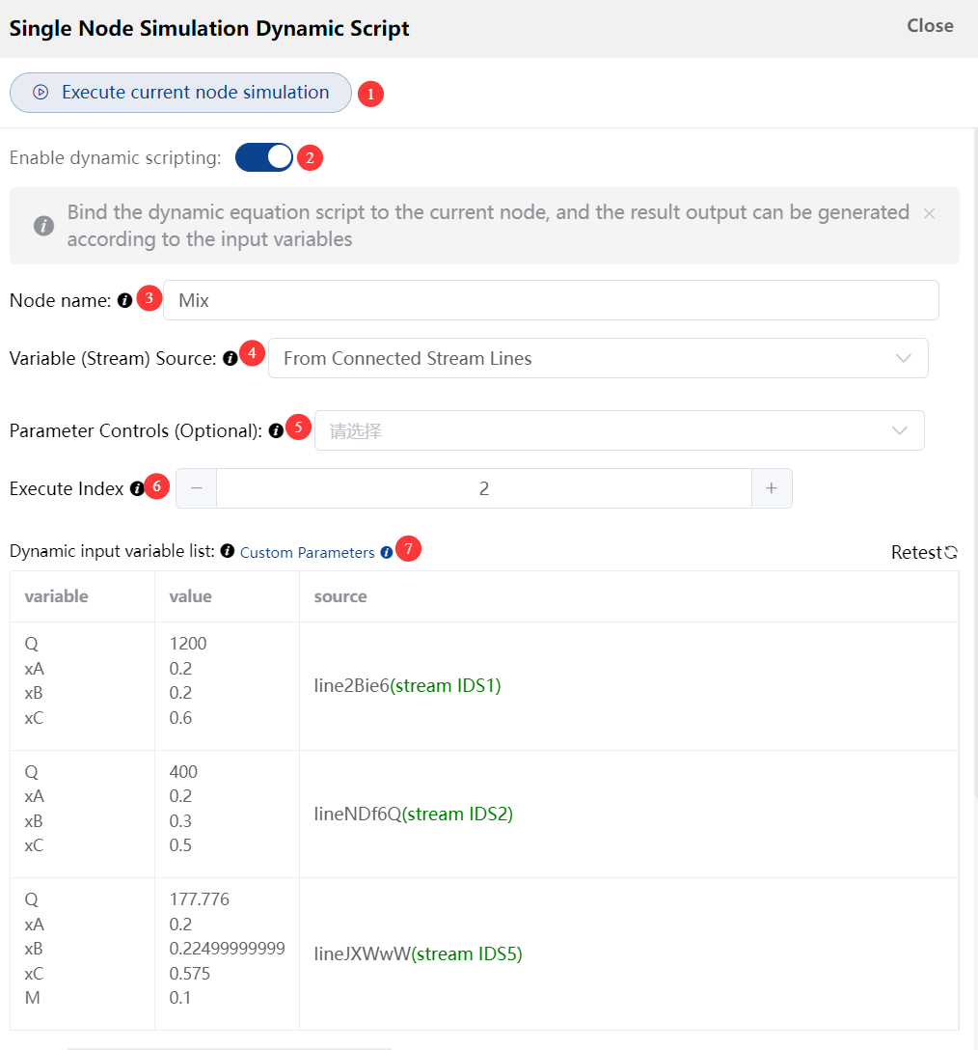
Figure 2-1 Node dynamic simulation configuration panel
1. Run single step — typically used for single-node debugging. (When debugging a single node, the global variables of upstream nodes cannot be obtained.)
2. Enable dynamic script — when the whole-canvas simulation model runs, only nodes with the dynamic script enabled are executed.
3. Specify simulation node name — defaults to the node key value.
4. Variable source: choose either "from upstream node output variables" or "from the incoming stream connectors (connectors)." Difference: the former takes all output variables of the upstream node (those not hidden downstream), while connectors can filter part of the variables, which suits scenarios with splits or recycles. For nodes without splits or recycles, the first option is simpler and faster. If the upstream node has several material streams (e.g., two pipes splitting 30%/70%), the downstream node should obtain variables from the material connectors. After choosing "from upstream node output variables," the system automatically identifies the upstream via the physical connector; you may also manually specify the upstream node in the dropdown (no connector needed), suitable for long-distance references.
5. Parameter Controls (Optional): When selecting variables from stream lines, you may also retrieve variables from other parameter components.
upstream: This option is available when selecting to retrieve variables from upstream nodes. It is commonly used for scenarios where physical connections cannot be established, yet variables from other nodes need to be accessed.
6. Node execution order index: the whole model executes nodes in ascending order of this value. If there is no recycle loop, the system assigns default values by connector order; if there is a recycle loop, you must assign values manually by execution order.
7. Dynamic input variables: by default, detects variables that can be referenced in Func (referenced directly in Func without declaration).

Common system variables and functions
These can be referenced directly in Func as variables, including the aggregate of input variables (SIAarray), the model run count (System_CTimes), the step size (dt), the node's live attributes (cNode), the basic math object (Math), and the advanced math object (IAnum). Note that these system variables are read-only and cannot be assigned.
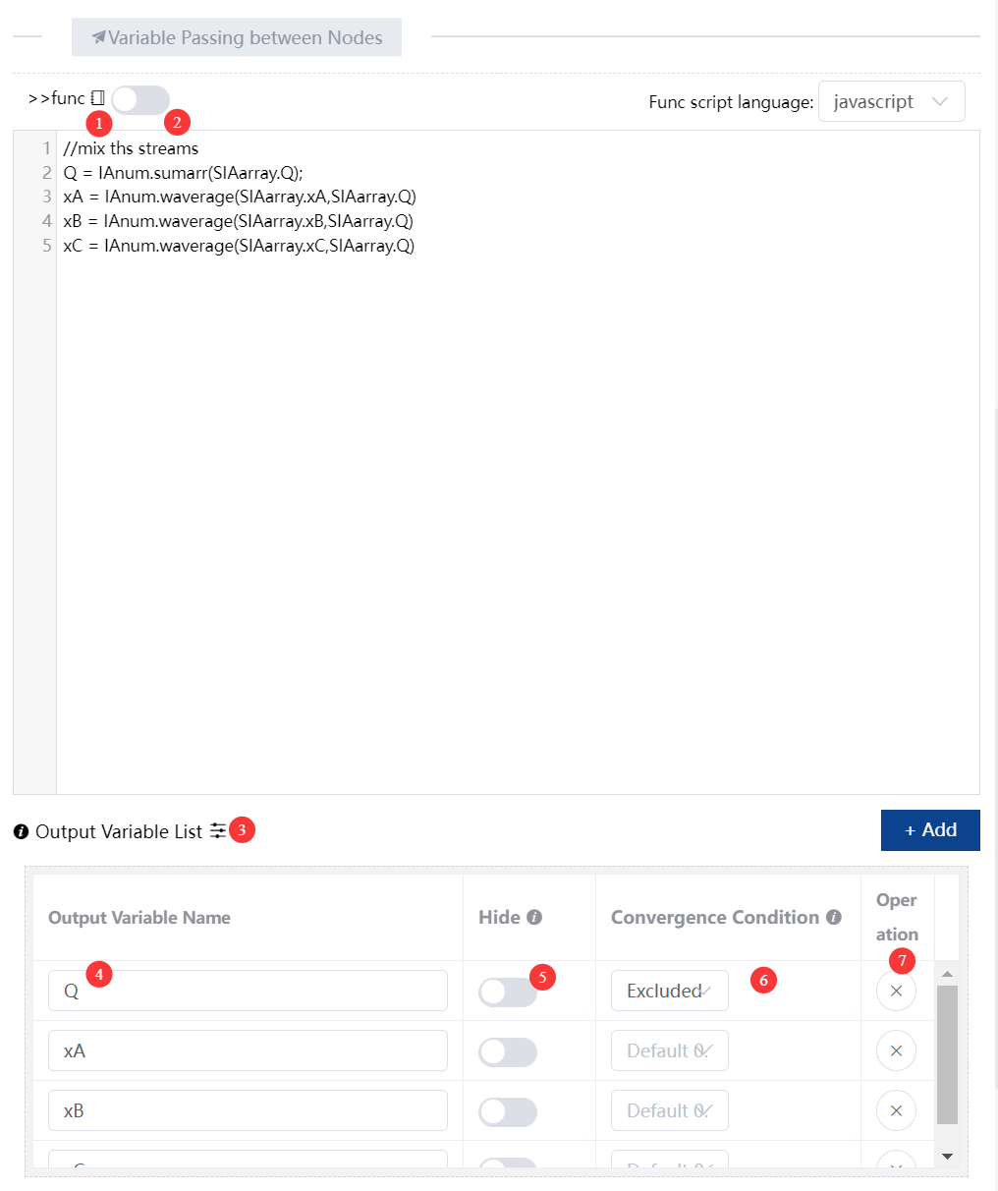
Figure 2-2 Func script editor and output variable list

1. The system variables here are all read-only values, including methods of the Math and IAnum objects.
Name | Description
SIAarray | Aggregate of all dynamic input variables; used for sums, averages, etc. Array format. E.g., two upstream nodes A (output m=1,n=2) and B (m=3,n=4,j=10) give SIAarray = {m:[1,3], n:[2,4], j:[10]}.
System_CTimes | Run step count; starts at zero and increments to the execution step count during simulation.
dt | System step size, set in the simulation menu; usable in both non-realtime and realtime simulation.
NodeKey (or NKey) | Unique key of the current node, composed of 12 characters.
cNode.width / height / x / y | Current live width / height / x-coordinate / y-coordinate of the node.
cNode.background | Current live background color; rgba(0,0,0,1) / #ddd / red forms all accepted.
cNode.borderwidth / bordercolor | Current live border width / border color.
cNode.angle | Current live rotation angle of the node.
Math | Mathematical Formulas and Constants
IAnum | IAnum Object Methods (Array Sum, Weighted Average, Median, etc.)

Additional annotations for Figure 2-2:
2. Enable subsystem: when enabled, the node computes via the subsystem model and outputs, bypassing the node's Func script.
3. Output-variable mode switch: table mode and text-editing mode. In table mode, you can set whether a variable is hidden downstream, the number of decimals kept, and convergence conditions. In text mode, multiple variables are entered one per line—handy when there are many output variables.
(Warning: Invalid variable name. Cannot start with digits, contain spaces or be reserved keywords.)
4. Output variable name: the variable name must satisfy JS naming rules—cannot start with a digit, contain a decimal point, JS keywords (let/const/if/else/switch/while, etc.), spaces, or quotation/punctuation marks. Chinese or English names are both allowed.
5. Hide downstream: after hiding, downstream nodes cannot read the variable, but downstream connectors and the node's own attributes/text can still read it.
6. Convergence condition: set for steady-state simulation; default relative convergence 0.1%.
7. Delete: delete this output variable.
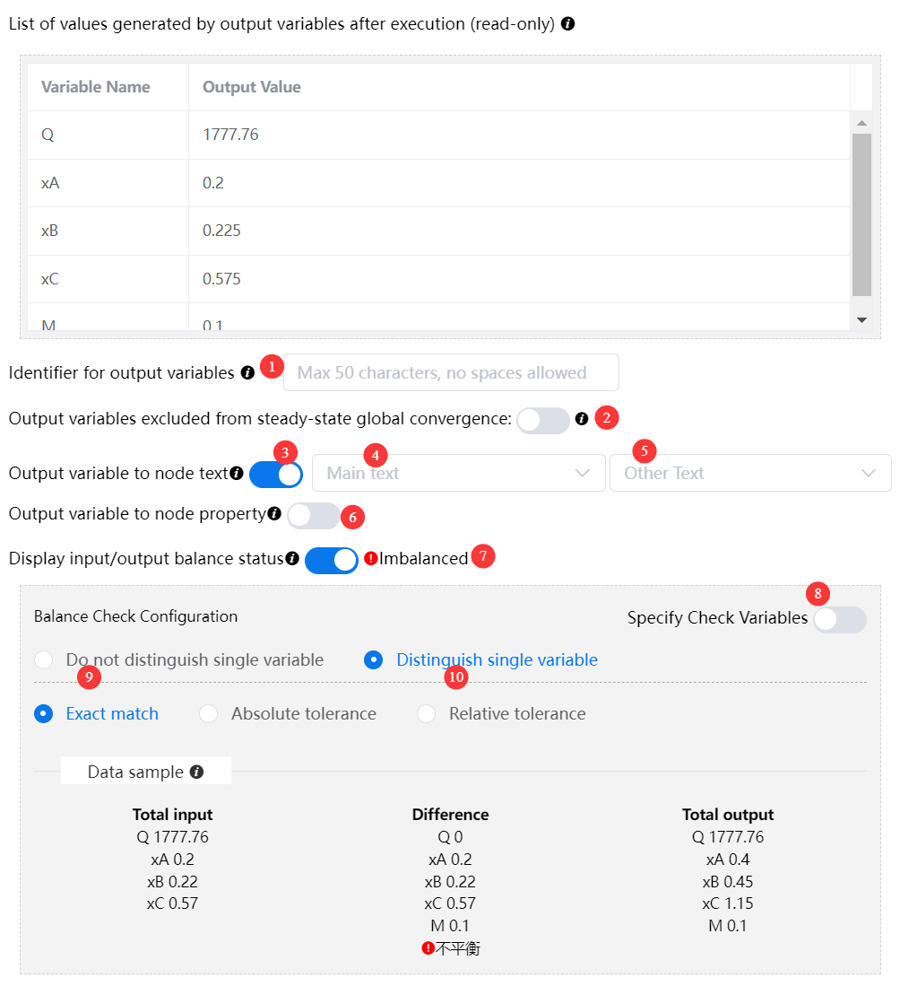
Figure 2-3 Output variable configuration and balance-check settings
1. Output variable identifier: used to add variable copies (e.g., identifier 1 on original variable Unit_Time gives copy Unit_Time1). Referencing them in the downstream node's Func works identically.
2. Exclude from global steady-state convergence: when the model iterates to steady state, this variable is not included in the global convergence judgment.
3. Output variable to node text: includes the main display text (the node's editable text on the canvas) and a hint sub-text.
4. Bind main display text to a variable: the text content becomes the value of the bound output variable.
5. Bind hint sub-text to a variable: the hint text content becomes the value of the bound output variable.
6. Output variable to node attributes: when enabled, the output value can be bound to the node's attributes.Node output binding variables: attributes include width, height, angle, border color/size, background color, canvas x/y position, etc. Used to display different states based on simulation results.
7. Show balance status: checks whether the variable values on the input connectors match those on the output connectors.
8. Specify check variables: Select variables for inlet-outlet balance check.
9/10. Balance-detection configuration: two methods—(1) without distinguishing variables, compare the sum of all input connector variables with the sum of all output connector variables; (2) distinguishing variables, compare each variable individually. For tolerance: if set to 10%, and input sum = 10 while output sum = 11, tolerance = (11-10)/10 = 0.1; if computed tolerance <= set tolerance, it is considered balanced. The same principle applies to variable tolerance in steady-state convergence.

2.1.2 Connectors: Tracks for Logic and Data Transfer
Connectors define the temporal relationships and data dependencies between nodes. They are not merely arrows; they are the pipes through which variables flow.
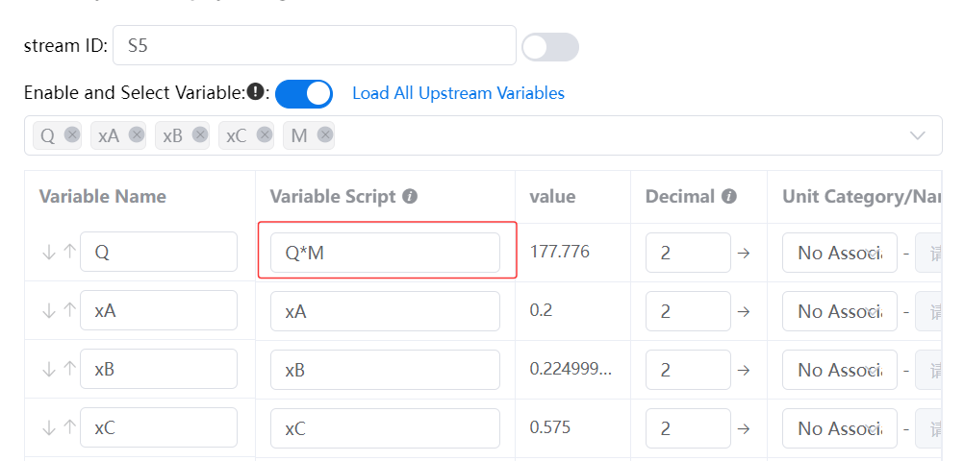
Figure 2-4 Stream line variable configuration panel
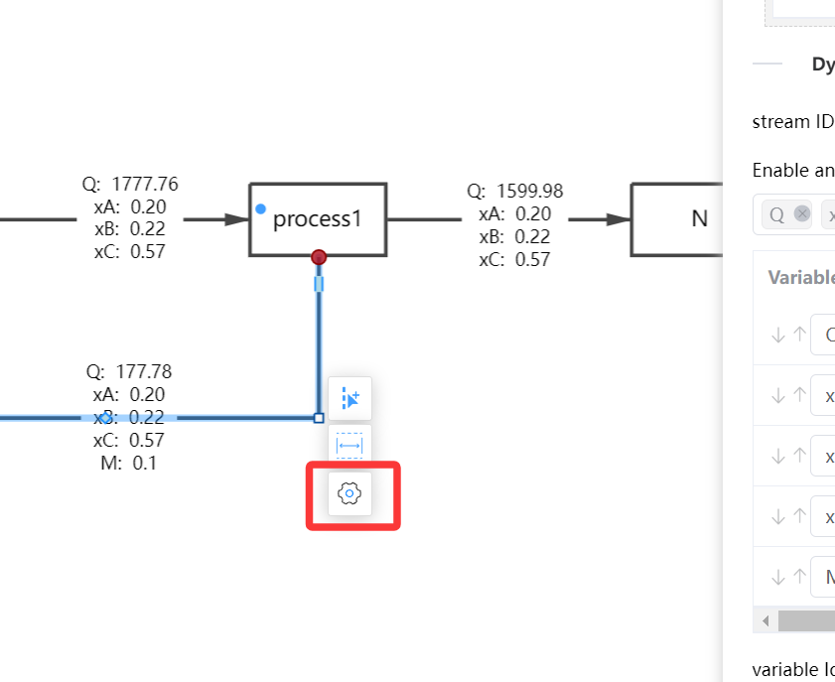
Figure 2-5 Opening the stream line configuration from the canvas
Stream Line Variables: If a variable value cannot be obtained, it defaults to 0; if a value is a string rather than a number, add single quotes.
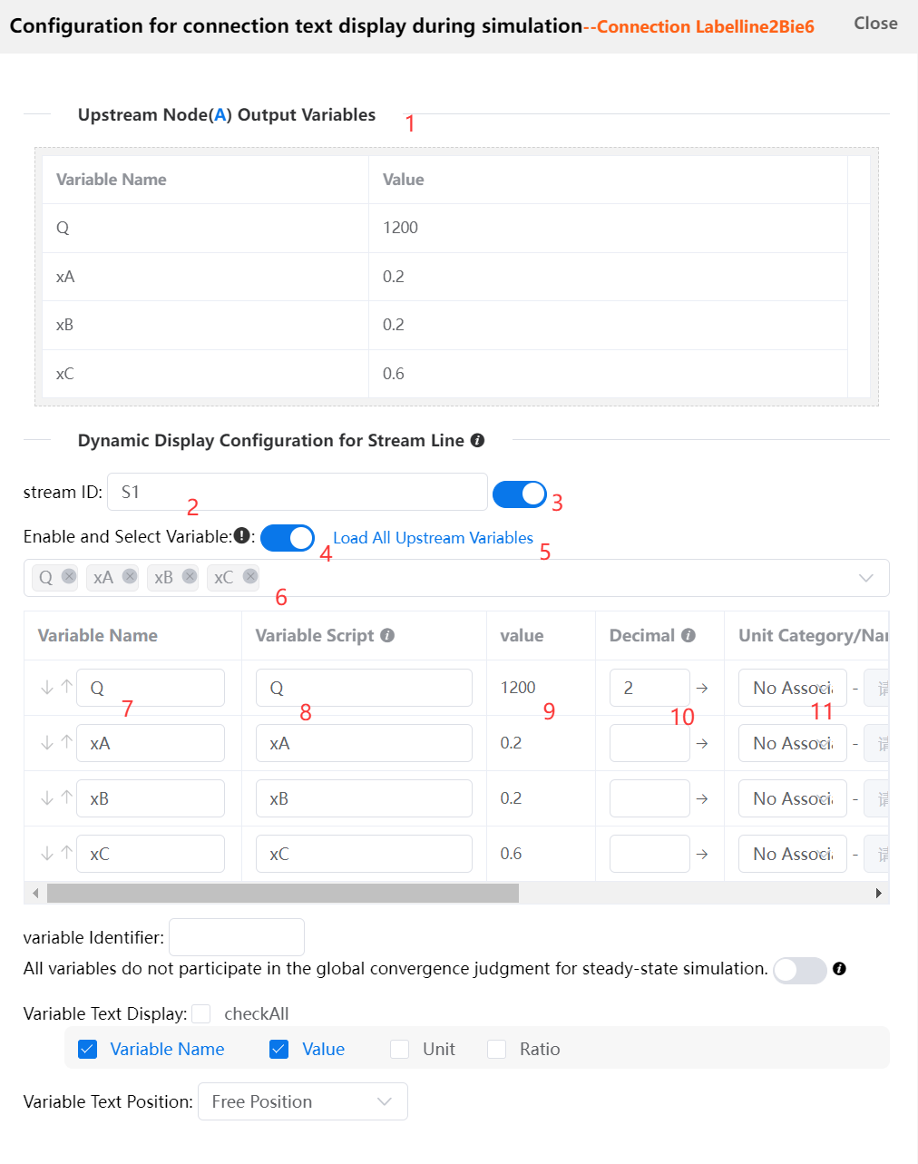
Figure 2-6 Connection text display configuration
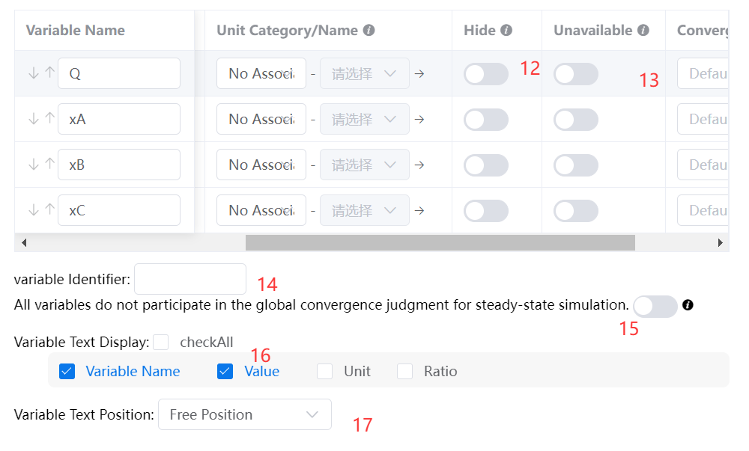
Figure 2-7 Stream line variable configuration: unit, visibility and conversion columns
1. Upstream Node Output Variable Value: The output variable value of the starting node of this stream line.
2. Stream ID: The name of the stream line.
3. Show Stream ID: Controls whether the stream ID is displayed on the connection line in the canvas.
4. Enable Connection Variables: When enabled, the destination node of the connection can retrieve variables via variable source.
5. Load All Output Variables of Upstream Node: Avoid tedious manual addition when there are many variables.
6. Select or Input Connection Variable: You may enter any custom variable name.
7. Connection Variable Name: Generated from item 6 or manually entered. Variable names cannot contain leading numbers or spaces.
8. Connection Variable Script: Direct numeric input is supported. Custom calculations can also reference the output variable in item 1.
9. Connection Variable Value: Result value after executing the connection variable script in item 8.
10. Decimal Places: Only controls the decimal digits displayed for value 9 on the connection line. The connection variable value received by downstream nodes remains unchanged.
11. Associated Unit: Unit display for the connection line on the canvas. Custom unit categories can be defined via Custom Unit Category/Name in the simulation toolbar.
12. Hide Variable: Hides the variable name and value of this stream line on the canvas.
13. Variable Disabled: The variable and its value cannot be read in downstream stream line variables.
14. Variable Tag: Same as node variable tags. Creates a new copy of the variable when appended to the variable.
15. Exclude All Connection Variables from Global Steady-State Convergence: When enabled, convergence checks for the current stream line are ignored in global simulation balance calculations that iterate automatically to steady state.
16. Variable Text Display: Content shown on this stream line in the canvas (connection variable name, variable value, unit, percentage ratio. The ratio requires a specified denominator variable, and the current variable value acts as the numerator).
17. Variable Text Position Relative to Stream ID: Assign a fixed relative position for variable text against the Stream ID.

2.1.3 Subsystems: Modular Encapsulation of Complex Models
Note: In a node's subsystem, the In node can obtain the parent node's input variables but cannot obtain the global variable object IA of the parent canvas. If common functions are needed inside the subsystem, they must be defined separately in a node in the sub-canvas.
For large systems, IAutoDrawSim supports modular encapsulation.
- Creation: a group of nodes and connectors that perform a specific function can be encapsulated into an independent subsystem node.
- Value: on the main canvas, a subsystem behaves as a "black box" component exposing only the necessary input/output interfaces. This realizes the engineering principle of "divide and conquer," greatly improving the readability, maintainability, and reuse rate of complex models.
- Usage: a node can create its own independent subsystem (right-click → Create Subsystem, or press S for a new canvas). The subsystem canvas must have at least one In node and only one Out node. Each In node can share the parent node's dynamic input-variable list as input, and output through the Out node after processing. The In and Out nodes are added to the canvas via the insertion toolbar's subsystem data-entry and data-exit nodes.
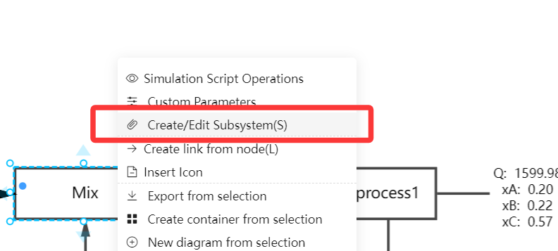
Figure 2-8 Creating a subsystem from the canvas

Other process-simulation modeling logic in a subsystem is the same as in the main system. In theory, subsystems can be nested more than three levels, but for manageability we generally recommend at most two levels.
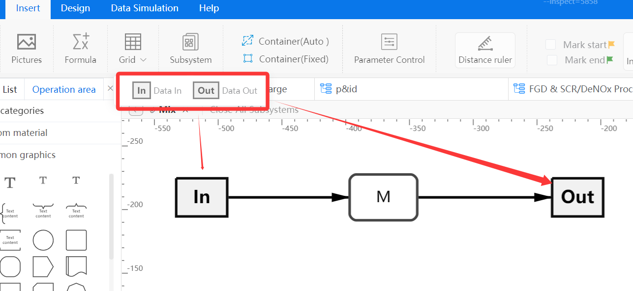
Figure 2-9 In and Out subsystem nodes on the insertion toolbar
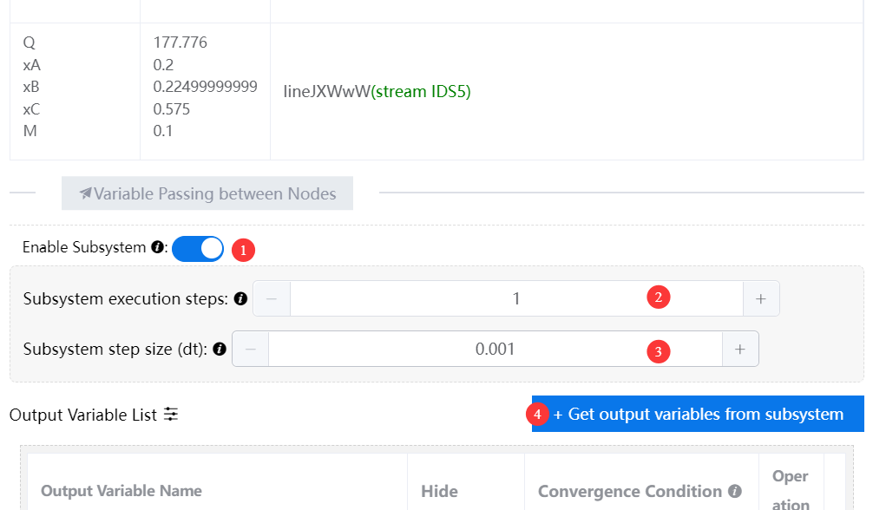
Figure 2-10 Subsystem configuration in the parent node
1. Enable subsystem in the parent node: when enabled, output follows the subsystem black-box simulation result; the node's Func script is not executed.
2. Subsystem run count: if the subsystem contains a recycle, specify the iteration steps needed to reach steady-state convergence.
3. Subsystem step size: set only if a node's Func references dt; otherwise leave default.
4. Get the subsystem's Out output variables: these cannot be manually specified; they are synchronized from the subsystem's Out node output variables. To change an output variable name, edit it in the subsystem's Out node output variables.

2.1.4 Simulation Toolbar: Model Control and Output
Simulation nodes and connectors form a simulation model; the simulation toolbar is where the model runs and produces results.
Figure 2-11 Simulation toolbar
1. Run model: clicking run executes each node's Func script (or subsystem) in sequential order (by execution-order value) and passes output values to downstream connectors. You can run directly or load data sources first (if a node's custom parameter links to an Excel data source, load Excel to update the parameters before running). The default maximum iteration count is 5000 (over 5000 iterations may be a performance bottleneck for larger models, and curves with more than 5000 data points may lag). To simulate 10,000 or 20,000 iterations, enable "Start from last simulation node" and simulate in batches of 500–2000 iterations each; the previous batch's ending data becomes the next batch's starting data. For example, after 1000 steps System_CTimes ends at 999 (from 0) and the next simulation starts from 999; all node/connector output variables start from the previous end. (Note: the global IA object is not reset in this mode; when the "Start from last simulation node" button is off, the global variables are cleared and reset on each run.)
2. Manual step iteration / auto-iterate to steady state: the former requires manual iteration count and is more flexible, suitable for both dynamic and steady-state simulation; the latter applies only to steady-state and non-realtime modes, with an upper limit of 100 iterations. If after 100 iterations all node output variables and connector values cannot reach the tolerance, an "unable to converge" error is raised. After converging, the iteration count is filled into the iteration-count field. In this case, manual step iteration is recommended.
3. Execution steps: the number of iterations the model must run. Step size: generally referenced in node Func; if not referenced, it need not be set.
4. Show input/output values on connectors: globally hide the dynamic variable display text on stream lines.
5. Custom Unit Category/Name: Set unit categories, which can be referenced and displayed on connection variables of stream lines.
6. Excel Source:Excel data sources can be introduced in custom parameters of nodes.
7. Data viewer: shows all node output variable values across all steps.
8. Publish isim file: publish the model as an independent, encrypted, compiled simulation file that cannot be edited or saved, only allowing node custom-parameter adjustment and running to obtain different results. Analogy: if the iax file is like a Word document, the isim file is like a PDF—the former can edit Func scripts and model logic, the latter is read-only.
9. Generate report: node basic attributes, custom parameters, output variable values, and connector variable values can all be exported to Excel via report generation.
10. Sensitivity analysis: specify a custom variable's range and simulation count (e.g., a recycle ratio R from 1–20 with 10 simulations) and the dependent-variable nodes; then run the whole model 10 times (the iteration count per run is set by items 2 and 3, e.g., 15 steps to converge). Note that the simulation count differs from the model iteration step count—the simulation count is layered on top of the iteration step count in the toolbar.
Sensitivity analysis example
Simulation 1: model iterates 15 steps, R=1, get dependent variable steady-state value
Simulation 2: model iterates 15 steps, R=3, get dependent variable steady-state value
Simulation 3: model iterates 15 steps, R=5, get dependent variable steady-state value
...
Simulation 10: model iterates 15 steps, R=19, get dependent variable steady-state value

2.2 Data-Driven Logic: Variables, Scoping, and Func Scripts
This is the soul of the IAutoDrawSim simulation engine. Its core design: all data are variables, and all logic can be scripted.

2.2.1 Multi-Source Injection of Input Variables and Data Integration
When a node's Func script executes, variables in its scope are automatically gathered from the following three sources, usable directly without any declaration:
Note: Re-declaring an input variable with let causes a SyntaxError.
- Custom-parameter variables: from the current values of controls on the node's parameter panel. This is the main entry for adjusting model behavior.
- External data variables (core feature): the node's custom parameter panel can be bound directly to an Excel file. At run time, the system automatically reads data from the specified sheet and range, mapping columns to same-named parameters. This lets the model use historical or planned data for driving, calibration, and batch scenario simulation.
- Upstream-passed variables: from upstream node output variables, or via a connector's Text-2 passed variables, or the display fields of a node connected to a data source (a realtime data-source-connected node's fields can serve as input variables for downstream simulation nodes). This is the channel for passing business context (e.g., order information, material attributes).

2.2.2 Explicit Output-Variable Declaration (Core Design)
IAutoDrawSim uses a clear, rigorous contract-style interface definition. Every node has an independent "output variable definition" text box.
- User-defined interface: in this box, list every data item the node exposes, one per line (e.g., final cost, delivery date, status code).
- Automatic assignment by the system: after the Func script runs, the system iterates the output list. For each variable name in the list, it finds a same-named variable in the execution environment and automatically assigns its value to that output item.
Design philosophy: "what I commit to output" is separated from "how I compute internally." This keeps node interfaces stable, making upstream/downstream connections and team collaboration clear and reliable.
Note: If an output variable is not found in the variable list, it must be declared in the Func script using the let/var keyword.

2.2.3 Func Scripts: Programming Focused on Business Logic
Under the framework of automatic variable injection and explicit output declaration, a Func script focuses purely on "how to compute."
IAutoDrawSim Func script standard pattern (JavaScript)
// Standard pattern for an IAutoDrawSim Func script
// Scenario: a production-processing node
// Known injected variables: MaterialQty (from upstream), UnitTime (from parameter panel/Excel),
// Efficiency (from parameter panel)
// Output list defined: ActualHours, DailyOutput, Status (if already in the dynamic input variable
// list, no need to declare with let)

// 1. Use injected variables directly (they already exist)
let theoreticalHours = MaterialQty * UnitTime;
let ActualHours = theoreticalHours / Efficiency; // assign to output 'ActualHours'

// 2. Compute and assign to other output variables
let DailyOutput = Math.floor(8 / UnitTime) * Efficiency; // assign to 'DailyOutput'

// 3. Set status based on business rule
let Status;
if (ActualHours > 10) {
Status = 'Delayed';
} else {
Status = 'Normal';
}
// All three variables in the output list are now correctly assigned.
Golden rule: make sure you assign a value in the Func script to every variable declared in the output list.

2.3 Simulation Execution, Analysis, and Extension

2.3.1 Simulation Execution and Control
- Run and debug: controls for single-step, pause, stop, and reset; single-node debugging lets you observe live changes of variable values.
- Scenario manager: when parameters are linked to Excel, run scenarios corresponding to multiple data rows in one click, automatically performing sensitivity analysis or Monte Carlo simulation.

2.3.2 Visualization and Insight Analysis
- Dynamic data binding: bind any variable to a graphical attribute (fill color, size, label) for "data-driven views."
- Charts and reports: built-in chart nodes automatically collect key performance indicators (KPIs) and generate trend, bar, and pie charts, exportable as images or Excel reports.

2.3.3 Advanced Integration and Extension
- Function library: call the built-in math, statistics, and logic function library in Func scripts, and extend it with custom functions.
- External invocation: mature models can be published as services and called by other business systems (e.g., ERP, MES) through APIs, providing simulation-based realtime decision support.

2.4 Advanced Techniques: Building Reusable Function Libraries
When building complex process models, you will often need to repeat the same utility functions (e.g., generating random numbers from specific distributions, mathematical conversions, or business-rule calculations) in different nodes' Func scripts. This is inefficient and a maintenance nightmare—when an algorithm changes, you must find and edit every node. This section introduces a core technique for code reuse: building a reusable function library using the IA global object or the window global object.

2.4.1 Extending the IA Global Object
As introduced in the basic tutorial, the IA object is a canvas-level global JavaScript object used to store cross-iteration state. Another powerful property is that it is a freely extensible JavaScript object: you can attach custom functions as its methods (properties), making them callable directly in every node's Func script throughout the model. The essence is to create a shared, globally visible utility library inside the model.

2.4.2 Creating and Using a Function Library
Step 1: create a "Global Init" node.
At the logical start of the canvas (before all business-logic nodes), add a node named Global Init or Function Library (execution-order index -999, executed first). Its only purpose is to execute once at simulation start to extend the IA object; it needs no delay function and no complex output variables.
Step 2: attach custom functions in the init node.
Global Init node Func script
// ===== Func script of the 'Global Init' node =====
// Runs once at simulation start (System_CTimes === 0).

// 1. Attach custom random-distribution functions (replacing per-node duplicates)
IA.norm = function(mean, stdDev) {
// Normal distribution (Box-Muller transform)
let u1 = Math.random();
let u2 = Math.random();
let z = Math.sqrt(-2.0 * Math.log(u1)) * Math.cos(2.0 * Math.PI * u2);
return z * stdDev + mean;
};

IA.exp = function(mean) {
// Exponential distribution, often used for inter-arrival times
return -mean * Math.log(Math.random());
};

// 2. Attach business-domain functions
IA.calculateTax = function(revenue, rate) {
// Compute tax
return revenue * rate;
};

IA.formatResult = function(value, unit) {
// Format an output result
return 'Result: ' + value.toFixed(2) + ' ' + unit;
};

// 3. Attach small utility functions
IA.clamp = function(value, min, max) {
// Clamp a number to a range
return Math.max(min, Math.min(max, value));
};
// Note: this node usually needs no output variable list.
// Its achievement is extending the IA object.
Step 3: call the functions directly in any business node.
After the init node runs, any subsequently executed node's Func script can call the defined methods directly like built-in functions, by referencing IA.functionName:
Calling custom functions in a business node
// In the 'Material-Readiness' node, use IA.norm directly
let processingTime = IA.norm(4.5, 0.8); // generate a normal-distribution random time

// In the 'Finance Calculation' node, use a business function
let taxPayable = IA.calculateTax(revenue, 0.13);

// In the 'Result Output' node, use utility functions
let displayValue = IA.clamp(rawValue, 0, 100);
let formattedInfo = IA.formatResult(displayValue, 'pcs');
Similarly, the following defines a custom mixed-material pH function IA.mixPH in a start node's Func (note: global-function definitions need no output variables; the function is attached directly under the global object IA):
Custom function example: mixed pH (attached to IA)
IA.mixPH = function(pHarray, Qarray){
/*
@param Qarray Array<number> flow rates of each stream
@param pHarray Array<number> pH of each stream
@return pHmix : mixed pH
*/
let sumQ = 0;
let sum_nH = 0; // total H+ molar flow
let sum_nOH = 0; // total OH- molar flow

const len = Qarray.length;
for(let i=0; i<len; i++){
const qi = Qarray[i];
const phi = pHarray[i];
const h = Math.pow(10, -phi);
const oh = Math.pow(10, phi - 14);
sumQ += qi;
sum_nH += qi * h;
sum_nOH += qi * oh;
}

let pH_mix;
const eps = 1e-20; // floating-point tolerance

if(sumQ < 1e-12){
pH_mix = 7.0;
}else if(sum_nH > sum_nOH + eps){
// H+ excess, acidic
const h_mix = (sum_nH - sum_nOH)/sumQ;
pH_mix = -Math.log10(h_mix);
}else if(sum_nOH > sum_nH + eps){
// OH- excess, basic
const oh_mix = (sum_nOH - sum_nH)/sumQ;
const pOH_mix = -Math.log10(oh_mix);
pH_mix = 14 - pOH_mix;
}else{
// exactly neutralized
pH_mix = 7.0;
}
// clamp pH to a reasonable 0-14 range
pH_mix = Math.max(0, Math.min(14, pH_mix));

return pH_mix;
};
Reference it in other nodes as IA.mixPH(SIAarray.pH, SIAarray.Q), where SIAarray.pH is the array of pH values of multiple streams and SIAarray.Q is the array of their flow values (see Case 3.1.2).

2.4.3 Extending window Global Functions
Unlike the IA object, the IA object is initialized at model run time (a global function IA.XXX defined in canvas A cannot be used in canvas B); its scope is limited to the current canvas (excluding subsystems). Functions attached to window are available throughout the current .iax file (including node subsystems). Therefore, only the more general custom functions should be attached to window. Example—a custom summation function:
Define a window-level global function
// Define a function that sums a, b, c
window.SUM = function(a,b,c){return a+b+c}
It can be used directly in the Func of any node on any canvas, or in a connector's custom variable script:
Calling a window global function
let m = 12;
let d = SUM(m,2,3); // call the window function directly without a prefix; d = 12+2+3 = 17

2.4.4 Advantages and Best Practices
Core advantages:
- Change once, effective everywhere: core algorithm logic is defined in one place. To optimize or fix, edit the single line in the Global Init node.
- Clean, readable models: business-node Func scripts are simplified, focusing on core process logic rather than utility-function implementation details.
- Promotes team collaboration and standardization: teams can share and maintain a unified, validated function library, ensuring consistent calculation logic across models.
- Unlimited extension: add any complex function to the IA object as project needs grow, seamlessly extending IAutoDrawSim's modeling capability.
Best-practice suggestions:
- Namespace management: if there are many functions, group them by module:
Namespace example (IA object)
// Create namespaces in the init node
IA.Finance = {};
IA.Finance.calculateVAT = function(...) {...};
IA.Finance.calculateDepreciation = function(...) {...};
IA.Utils = {};
IA.Utils.formatDate = function(...) {...};
Namespace example (window object)
// Or on window
window.Finance = {};
window.Finance.calculateVAT = function(...) {...};
window.Utils = {};
window.Utils.formatDate = function(...) {...};
- Write clear function documentation: in the init script, comment each function's purpose, parameters, and return value for team understanding.
- Robustness: add necessary parameter validation and basic error handling in custom functions to make model debugging easier.
- Performance: for computationally heavy or frequently called functions, mind their performance impact. Centralized definition also makes performance analysis and optimization easier later.

2.4.5 Cross-Node References (Long-Distance Data Reads)
When a node needs to read data from another node or connector but drawing a physical connector is inconvenient or unnecessary, use the following methods. Cross-node reference is an advanced feature; it is recommended only for read-only scenarios such as monitoring, validation, and dashboards. The main process's material and energy flows should still be expressed with physical connectors.
Recommended: import an upstream node's output variables via the dropdown.
In the node's dynamic simulation configuration panel, set "variable source" to "from upstream node output variables," then manually specify the target upstream node in the dropdown. No physical connector is drawn; the imported variables are injected into the current node's Func scope, equivalent to a physical connector but without the line on the canvas. Suitable for long-distance monitoring nodes or auxiliary references when layout is constrained.
Auxiliary: implicit reference in Func (use with caution).
The following syntax reads the live value of any node or connector directly in Func. Because it does not go through a physical connector, it can make model logic unreadable and hard to debug; it is not recommended in the main process.
- Reference node output variable: N.nodeName.variableName
nodeName corresponds to the nodesetid (custom simulation node name) in the dynamic script panel, and must be globally unique. Example: let a = N.Feed.Q; // read the output variable Q of the 'Feed' node. Constraint: the referenced node's funcindex must be less than the current node so the data is ready at execution time.
- Reference connector variable value: L.streamNo.variableName
streamNo corresponds to the funcindex in the connector configuration (e.g., 'S1Feed') and must be globally unique. Example: let b = L.S3Split.Q; // read the Q value of the 'S3Split' connector after split-ratio calculation. Note: this reads the connector's Text-2 variable value after mapping/scaling, not the upstream node's raw output.
Important warning
- Overusing implicit references (N./L.) causes the canvas to fail to reflect the true data dependencies, making model handover and maintenance very costly.
- If the main process uses implicit references extensively instead of physical connectors, IAutoDrawSim's core advantage of "what you see is what you simulate" is lost.
- Recommended convention: any material, energy, or information flow that forms the main process must use physical connectors; N./L. syntax is limited to auxiliary nodes such as corner dashboards, total-recovery statistics, and material-balance checks.

2.4.6 Application in This Book's Cases
In Chapter 3 and all later cases, we default to this engineering best practice. Every case's model includes a Global Init node that preloads the case-specific function library. Case explanations will point out which calculations directly call custom functions on the IA object to demonstrate their use. Readers are encouraged to apply the case libraries to their own projects, building their own "modeling arsenal."

Chapter Summary: The Three Core Modeling Principles
Before entering Chapter 3, keep these principles in mind throughout your modeling work. They form the "three core" principles of efficient modeling in IAutoDrawSim:
- Stream data flows via connector mapping: for core business data that follows the process sequence and evolves (orders, materials, customer info), use connector mapping to express its flow path and transformation clearly. This is the most intuitive.
- Model parameters are tuned via panel + Excel: for parameters that control model logic and need frequent trial and error, define them on the custom parameter panel for interactive adjustment; for batch, historical, or externally sourced data, inject them through the panel's Excel connection for data-driven operation.
- Internal logic is written in Func scripts: a node's core computation, decisions, and business rules are encapsulated in Func scripts. The script only needs to take inputs from automatically injected variables and assign values to items declared in the output-variable list, maintaining high cohesion and reusability.
In Chapter 3, we will see how these principles are applied smoothly across complex scenarios in different industries, turning static flow diagrams into dynamic, calculable, experimental, and optimizable digital laboratories.

Chapter 3 Industry Case Studies: From Principles to Solutions
Having mastered the core features and modeling principles of IAutoDrawSim in the first two chapters, we now turn theory into the ability to solve real problems through a series of cross-industry cases. We follow the core principles—"stream data flows via connectors, model parameters via the panel, core logic via scripts"—and show, hands-on, how to build clear, powerful, and maintainable simulation models for different domains.
The case library is organised as a domain / complexity matrix, so that you can find a direct reference for your own industry and also progress from easy to hard. The cases fall into four domain groups:

3.1 Introduction to the Cases
Group 1 - Process industry: simulating the material, energy and information flows of physical or chemical processes, usually involving rigorous formulas, recycle loops and state transitions.
Group 2 - Discrete manufacturing and logistics: production lines, takt time, equipment utilisation, warehousing and distribution networks, where the analysis is driven by queues, resources and random arrivals rather than by chemistry.
Group 3 - Business and service processes: order-to-cash, procure-to-pay and approval workflows, where the entities are documents and the resources are people and systems.
Group 4 - Research, education and public services: system dynamics, teaching simulators, traffic and evacuation studies, where the model is a sandbox for exploring behaviour.
The five worked cases that follow concentrate on Groups 1 and 3, because they exercise the widest range of IAutoDrawSim features: connector mapping, Func scripts, subsystems, the Excel data source and steady-state convergence.
Case | Domain group | Core simulation objective | Key IAutoDrawSim features | Complexity
1. Multi-component material mixing and splitting | Process industry | Sum and weighted-average of multiple same-named variables arriving on several parallel streams, then split the mixed stream by ratio. | Nodes as mixers; connectors as material streams; IAnum.sumarr / IAnum.waverage; split expressions written on the connectors. | ★★☆
2. Reversible esterification with recycle - steady-state material balance | Process industry | Converge a closed recycle loop and close the global material balance of a reversible reaction. | Closed loop with manually assigned execution order; steady-state iteration and convergence tolerance; equilibrium equation solved inside a Func script. | ★★★
3. Reversible esterification with recycle - material and energy balance | Process industry | Add a coupled energy balance: temperature-dependent equilibrium, adiabatic reactor, enthalpy carried on the streams. | Component flows plus temperature and enthalpy on the same connector; weighted-average heat capacity; enthalpy scaled by molar split ratio. | ★★★
Table 3-1 Case matrix: domain group, objective, key features and complexity

3.2 Case 1 (Basic): Multi-Component Material Mixing and Splitting

Business Scenario and Pain Points
Business background. Multi-component material mixing and splitting is a core basic unit operation in the chemical, pharmaceutical, food, and new-energy industries. In production, several raw materials of different flows and compositions must be mixed and homogenized, then split in fixed proportions according to production-line load and downstream requirements. This structure is typical and versatile—a core hands-on case for learning standardized continuous-process modeling in IAutoDrawSim.
Core pain points.
- Process display is not intuitive: multi-feed, mixing, and multi-level splitting have no standardized graphical model; material direction and hierarchy are vague, hindering handover and teaching.
- Process rules are not fixed: mixing ratios and split proportions rely on field experience with no digital model archive, so iterations and personnel changes can introduce parameter drift that affects production stability.
- Abnormal tracing is inefficient: without a structured process chain, when ratio imbalance, flow anomalies, or feed-supply imbalance occur, the fault node cannot be located quickly.
- Poor model reuse: similar production scenarios share the same logic, but without a generic standardized template, every model is rebuilt from scratch.
Modeling objective.
- Realize process visualization: build a complete standardized model showing the full chain of multi-component feed, mixing, proportional split, and multi-branch output with clear hierarchy.
- Fix standardized process: bind mixing ratio, split ratio, and flow constraints as core process parameters, turning experience into an archivable, editable, iterative digital standard.
- Improve abnormal troubleshooting: clarify upstream/downstream relationships of each unit, supporting fast tracing of mixing/splitting anomalies.
- Master core modeling skills: through a typical case, master node construction, connector routing, parameter configuration, and standardized output in IAutoDrawSim.

Modeling Steps and Node Design
The model uses the three feed streams listed in Table 3-2. The custom parameter panel of each inlet boundary node carries the total flow Q and the three mass fractions.
Inlet node | Q (kg/h) | xA | xB | xC | Stream ID
S1_Inlet-1 | 2000 | 0.10 | 0.60 | 0.30 | S1 Feed
S2_Inlet-2 | 800 | 0.20 | 0.50 | 0.30 | S2 Feed
S3_Inlet-3 | 1200 | 0.05 | 0.70 | 0.25 | S3 Feed
Table 3-2 Feed streams of Case 1
Step 1: drag a material-inlet arrow icon as the material input. Its configuration:
- Custom parameter panel (values show as a floating panel above the node for direct adjustment): Q (total flow, kg/h, default 2000); xA (mass fraction of A, default 0.1); xB (mass fraction of B, default 0.6); xC (mass fraction of C, default 0.3).
- Func script: empty (output directly via the custom output variables below).
- Output variables (one per line): Q, xA, xB, xC.
Step 2: copy the material-inlet boundary node three times (custom parameters, Func, and output variables are the same; only the values differ).
Step 3: add material-stream connectors from the material nodes to the downstream mixer node.
Set the first material input node's outflowing stream number to "S1 Feed," referencing the connector's start-node output variables; reference Q, xA, xB, xC globally. Set the other two connectors the same way, with stream numbers "S2 Feed" and "S3 Feed." Also check the variable-name-and-value option on the material-connector configuration panel so both names and values display on the connectors.
Step 4: mix the multiple input material streams in the mixer. Note the mixer's variable source must be set to "from the incoming material (stream) connectors." Its Func script:
Mixer node — Func script
Q = IAnum.sumarr(SIAarray.Q);
xA = IAnum.waverage(SIAarray.xA, SIAarray.Q)
xB = IAnum.waverage(SIAarray.xB, SIAarray.Q)
xC = IAnum.waverage(SIAarray.xC, SIAarray.Q)
This uses IAnum.sumarr(arr) (array summation) and IAnum.waverage(arrA, arrB) (weighted average). More built-in IAnum functions can be viewed directly in the software:
IAnum object functions | Explanation
IAnum.sumarr(arr) | Sum the elements of array arr; returns the value.
IAnum.waverage(arrA, arrB) | Compute the weighted average of array A. Example: arrA=[10,90], arrB=[2,3]; result = (10*2+90*3)/(2+3) = 54.
IAnum.statistic.mean(arr) | Mean of the array; returns array. (E.g., mean of multiple input Q: IAnum.statistic.mean(SIAarray.Q))
IAnum.statistic.median(arr) | Median of the array; returns array.
IAnum.statistic.mode(arr) | Mode of the array; returns array. (E.g., mode of multiple input Q: IAnum.statistic.mode(SIAarray.Q))
IAnum.statistic.standardDev(arr) | Standard deviation of the array; returns array. (E.g., std dev of multiple input Q: IAnum.statistic.standardDev(SIAarray.Q))
The mixer's output variables are Q, xA, xB, xC.
Step 5: after mixing, output through the upper and lower material-stream connectors. Set the stream numbers of the two output connectors to "S4-1 Split" and "S4-2 Split," and set the custom variable scripts of Q in their reference-variable lists to Q*0.4 and Q*0.6. Because the mass fractions of the components are the same in both streams, you only need to reference the upstream Q variable and process it.
Case summary: it is generally recommended that a node reference the configured variables on the input material-stream connectors into Func for calculation, because referencing upstream node output variables can produce many redundant variables and is less intuitive.

Steady-state results and validation
A single run of the simulation toolbar executes the three inlet nodes, the mixer and the two split connectors in execution order and produces the values in Table 3-3.
Validation: the flow balance closes, 2000 + 800 + 1200 = 4000 = 1600 + 2400, and the mass fractions sum to 1.000 at every point. The mixer value of xA is reproduced by hand as (2000x0.10 + 800x0.20 + 1200x0.05) / 4000 = 0.105, which is exactly what IAnum.waverage returns.
Note that a split does not change composition. Only the total flow is scaled, which is why the two output connectors reference Q alone and pass xA, xB and xC through unchanged.
Node / stream | Q (kg/h) | xA | xB | xC
S1_Inlet-1 | 2000 | 0.100 | 0.600 | 0.300
S2_Inlet-2 | 800 | 0.200 | 0.500 | 0.300
S3_Inlet-3 | 1200 | 0.050 | 0.700 | 0.250
MIX_Mixer (S4 Mixed) | 4000 | 0.105 | 0.610 | 0.285
S4-1 Split (40 %) | 1600 | 0.105 | 0.610 | 0.285
S4-2 Split (60 %) | 2400 | 0.105 | 0.610 | 0.285
Table 3-3 Case 1 converged results
Tip: besides splitting the upstream Q directly on the connector, you can also define Q_up and Q_down variables on the upstream node, process them in the upstream node's Func, and reference Q_up and Q_down on the connectors. The drawback is that the upstream node needs a few extra variable names.

3.3 Case 2 (Intermediate): Reversible Esterification with Recycle — Steady-State Material Balance

Business Scenario and Pain Points
Business background. Ethyl acetate is a typical organic esterification product. The reaction is a reversible equilibrium: acetic acid reacts with ethanol to produce ethyl acetate and water. In actual production, unreacted raw materials are separated and recycled to the reactor inlet to improve utilization. Traditional design phases often use manual Excel calculation of the material balance, requiring tedious trial-and-error iteration of the recycle loop—inefficient and error-prone—and the PFD drawing and calculation data are disconnected, so parameter changes require syncing both the drawing and the table, with poor version consistency.
Core pain points.
- Tedious recycle iteration: manual trial-and-error convergence of a closed recycle loop is difficult, and multi-option comparison repeats the work.
- Drawing-data separation: the flow diagram is illustrative only; material-balance data is stored separately, making handover and parameter changes error-prone.
- Poor fit for non-standard rules: standard chemical software is cumbersome to configure for custom separation ratios and custom equilibrium constants.
Modeling objective.
Based on IAutoDrawSim's integrated "draw-and-compute" architecture, build a steady-state material-balance model of a reversible esterification with recycle:
- Draw the process directly on the canvas; the closed recycle loop auto-iterates to convergence without manual tear-stream handling.
- Embed equilibrium-reaction computation in the node, supporting quick adjustment of feed amounts, recycle ratio, and equilibrium constant.
- Output all stream component flows in one click and automatically validate the global material balance.
- The model is reusable and encapsulatable for fast estimation of similar reversible-reaction + recycle schemes.

Reaction Principle and Process Flow
Reaction equation. HAc (acetic acid) + EtOH (ethanol) ⇌ EA (ethyl acetate) + H₂O (water). Component abbreviations: HAc, EtOH, EA, H₂O. Constant-temperature equilibrium constant K = 4.0 (molar-flow-ratio basis, ideal-solution approximation).
Derivation: solving the quadratic equation for the relationship between inputs/outputs of HAc, EtOH, EA, H₂O and the equilibrium constant K. For the reversible reaction CH₃COOH + C₂H₅OH ⇌ CH₃COOC₂H₅ + H₂O, let the reactor inlet molar flows be HAc, EtOH and EA = H₂O = 0 (simplified: no product at inlet). Let reaction progress ξ be the hourly consumption of ξ HAc and ξ EtOH, producing ξ EA and ξ H₂O. Reactor outlet: HAc-ξ, EtOH-ξ, ξ, ξ. By the equilibrium constant (molar-ratio, ideal system) K = ξ²/((HAc-ξ)(EtOH-ξ)), rearranging gives the standard quadratic a·ξ² + b·ξ + c = 0 with a = 1-K, b = K(HAc+EtOH), c = -K·HAc·EtOH.
Process flow.
Fresh feed S1 + recycle S4 → mixer MIX → reversible reactor REA → separator SEP.
- Product EA goes entirely to the S3 product stream.
- Reaction water H₂O goes entirely to the S5 wastewater stream.
- Unreacted HAc, EtOH: 90% recycle via S4 to the mixer; 10% leaves with the S5 wastewater.
Node execution order.
S1_FreshFeed (0) → MIX_Mixer (1) → REA_Reactor (2) → SEP_Separator (3). The recycle stream returns from the separator outlet to the mixer inlet, forming a closed loop that converges automatically through multi-round steady-state iteration.

Modeling Steps and Node Configuration
Step 1: create the model framework.
Create the four core nodes in order on the canvas and connect them with material-stream connectors, with one recycle line from SEP back to the MIX inlet to form a closed loop.
Step 2: configure each node in detail.
Prerequisite: first add a flow unit kmol/h in the dynamic-line-width editor of the simulation toolbar, for use in the current canvas's material-stream variable references.
Node 1 — S1_FreshFeed (execution-order index 0).
Function: boundary condition, sets the fresh-feed component flows.
- Custom parameter panel: HAc and EtOH, with the values listed in Table 3-4 (right-click the node's custom parameters to open the panel, or open it in the dynamic script panel).
Item | Symbol | Value | Unit
Fresh feed, acetic acid | HAc | 100.00 | kmol/h
Fresh feed, ethanol | EtOH | 120.00 | kmol/h
Equilibrium constant (298.15 K) | K0 | 4.00 | -
Recycle ratio of unreacted HAc and EtOH | R | 0.90 | -
Steady-state convergence tolerance | - | 0.1 | %
Maximum auto-iteration steps | - | 100 | -
Table 3-4 Feed conditions and separation parameters of Case 2
Table 3-4 collects the feed conditions and the separation parameters used by the whole case. HAc is acetic acid, EtOH is ethanol, EA is ethyl acetate.
- Func script: none (output custom parameter values directly).
- Output variables: HAc, EtOH.
Node 2 — MIX_Mixer (execution-order index 1).
Function: mix the fresh feed and the recycle stream (note variable source—from the incoming material-stream connectors). Variable source: from the incoming material (stream) connectors (two feeds: S1 fresh feed, S4 recycle).
MIX_Mixer — Func script
// Sum the component flows of the multiple feeds respectively
HAc = IAnum.sumarr(SIAarray.HAc);
EtOH = IAnum.sumarr(SIAarray.EtOH);
Explanation: SIAarray automatically aggregates the same-named variable arrays of all input connectors; IAnum.sumarr() is the built-in array-summation function. Output variables: HAc, EtOH.
Node 3 — REA_Reversible Reactor (core, execution-order index 2).
Function: solve the reversible-reaction outlet component flows from the equilibrium constant. Variable source: from upstream node output variables (if the upstream node has multiple material-stream splits, it is recommended to get variables from the material-stream connectors). Input variables: HAc, EtOH (reactor-inlet component molar flows).
REA_Reversible Reactor — Func script
// Esterification equilibrium constant (constant-temperature assumption)
const K = 4.0;

// Define product variables EA (ethyl acetate) and H2O (water); the EA and H2O input from the S2
// connector are 0, so define them as 0.
let EA = 0;
let H2O = 0;

// The equilibrium equation reduces to a quadratic a*xi² + b*xi + c = 0 (derived at the start of
// this section): inputs HAc, EtOH and outputs...
let a = 1 - K;
let b = (EA + H2O) + K * (HAc + EtOH); // since recycled EA and water are 0, equivalent to b=K*(HAc+EtOH)
let c = EA * H2O - K * HAc * EtOH; // equivalent to c = -K*HAc*EtOH

// Solve the quadratic and take the valid root
// Reaction progress xi: consumes xi HAc and xi EtOH per hour; produces xi EA and xi H2O
let xi = 0;
let delta = b * b - 4 * a * c;

if (delta >= 0) {
let xi1 = (-b + Math.sqrt(delta)) / (2 * a);
let xi2 = (-b - Math.sqrt(delta)) / (2 * a);
// Filter the valid root: xi>0 and not exceeding the minimum reactant amount
let maxXi = Math.min(HAc, EtOH);
if (xi1 > 0 && xi1 <= maxXi) {
xi = xi1;
} else if (xi2 > 0 && xi2 <= maxXi) {
xi = xi2;
}
}

// Compute the outlet component flows
HAc = HAc - xi;
EtOH = EtOH - xi;
EA = EA + xi;
H2O = H2O + xi;
Explanation: solve the equilibrium equation directly in JavaScript within the node Func—no global simultaneous solver needed; each iteration automatically computes the equilibrium outlet composition under the current inlet conditions. Output variables: HAc, EtOH, EA, H2O.
Node 4 — SEP_Separator (execution-order index 3).
Function: separate the product, recycle, and wastewater streams per the process rules. Variable source: from upstream node output variables or from the incoming connector (either works because the upstream node has no split).
- Custom parameter: define a recycle-ratio variable R (used for split calculation on the material connectors, default 0.9).
- Input variables: HAc, EtOH, EA, H2O.
- Func script: none.
- Output variables: EA, HAc, EtOH, H2O, R.
On the S4 recycle connector: only HAc and EtOH; use the SEP output HAc and EtOH multiplied by the split ratio R. On the S3 product connector: EA. On the S5 wastewater connector: HAc and EtOH multiplied by (1-R); H2O does not recycle and is discharged directly.
Node 5: the product-output and wastewater-discharge nodes (optional, may be configured or not).
Step 3: once every node and connector's input/output and Func script is configured, run the simulation toolbar.
- Simulation mode: steady-state.
- Iteration method: custom iterate to steady state.
- Convergence tolerance: default 0.1% (stop iterating when all output variables change by less than this relative amount).
- Steady-state maximum auto-iteration: 100 steps (this case converges in about 40–70 steps). If a complex scenario cannot converge in 100 steps: 1) use manual iteration count to iterate manually (manual max 5000 steps); 2) optimize the model to find the cause of non-convergence.
Step 4: miscellaneous (you can insert a list on the canvas to display node custom parameters or connector material data).

Simulation Results and Validation
Table 3-5 lists the converged steady-state results (unit: kmol/h). The system has one feed, S1; the products leaving the boundary are S3 (product) and S5 (wastewater). S4 is the internal recycle stream and does not take part in the global balance.
Stream | HAc | EtOH | EA | H2O | Kind
S1 Fresh feed | 100.00 | 120.00 | 0.00 | 0.00 | boundary in
S2 Reactor feed (after mixing) | 110.40 | 310.21 | 0.00 | 0.00 | internal
S2R Reactor outlet | 11.56 | 211.37 | 98.85 | 98.85 | internal
S4 Recycle to mixer | 10.40 | 190.23 | 0.00 | 0.00 | internal loop
S3 Product | 0.00 | 0.00 | 98.85 | 0.00 | boundary out
S5 Wastewater | 1.16 | 21.14 | 0.00 | 98.85 | boundary out
Table 3-5 Case 2 converged steady-state material balance (kmol/h)
- HAc: input 100.00 = wastewater 1.16 + reacted 98.84 ✔
- EtOH: input 120.00 = wastewater 21.14 + reacted 98.86 ✔
- EA: generated 98.85 = product 98.85 ✔
- H₂O: generated 98.85 = wastewater 98.85 ✔
Equilibrium-constant validation: recomputing K from the reactor outlet of Table 3-5 gives K = 98.85 x 98.85 / (11.56 x 211.37) = 4.00, consistent with the value set for the reactor.

Case Summary
- Closed recycle auto-handling: no need to define tear streams manually; converges automatically through multi-round steady-state iteration, far more efficient than manual Excel trial-and-error.
- Drawing-and-compute integration: the PFD canvas is the calculation model; after changing feed, recycle ratio, or equilibrium constant, recalculate in one click with drawing and data updated together.
- High flexibility: write the equilibrium equation and separation rules directly in the node Func, supporting fast customization of non-standard processes without a built-in unit-model library.
- Accuracy note: at the pure material-balance level, results agree with the ideal models of professional chemical simulators; if real-solution activity effects are needed, correct the equilibrium constant K from property data before computing.
- Extensibility: following the Chapter 4 encapsulation method, this case can be encapsulated as a generic reversible-reaction + recycle component and stored in the component library for reuse.

3.4 Case 3 (Intermediate): Reversible Esterification with Recycle — Material and Energy Balance
This case adds an energy-balance part on top of the material balance in Case 3.
- Foundation: keep the original S1_FreshFeed / MIX_Mixer / REA_Reactor / SEP_Separator node structure, execution order, and separator connector split logic of Case 3 unchanged.
- Change from constant temperature to non-isothermal: the reaction equilibrium constant K varies with temperature; streams carry component flows + temperature T + total enthalpy H; the reactor operates adiabatically.
- Enthalpy reference: H = Σ(n_i · Cp_i · (T - Tref)). Units: flow (kmol/h), enthalpy (kJ/h), molar heat capacity (kJ/(kmol·K)), reaction enthalpy (kJ/kmol).
Table 3-6 lists the component molar heat capacities (constant approximation) and the remaining thermophysical parameters of the case.
Parameter | Symbol | Value | Unit
Enthalpy reference temperature | Tref | 298.15 | K
Molar heat capacity, acetic acid | Cp,HAc | 120 | kJ/(kmol K)
Molar heat capacity, ethanol | Cp,EtOH | 115 | kJ/(kmol K)
Molar heat capacity, ethyl acetate | Cp,EA | 170 | kJ/(kmol K)
Molar heat capacity, water | Cp,H2O | 75 | kJ/(kmol K)
Equilibrium constant at 298.15 K | K0 | 4.00 | -
Reaction Gibbs free energy (correlation parameter) | dGr | -3400 | kJ/kmol
Molar reaction enthalpy | dHr | -22000 | kJ/kmol
Universal gas constant | Rg | 8.314 | kJ/(kmol K)
Feed temperature | T | 300 | K
Recycle ratio | R | 0.90 | -
Table 3-6 Thermophysical parameters of Case 3
First, define a public parameter component (which can be referenced in any node): component molar heat capacities Tref, CpHAc, CpEtOH, CpEA, CpH2O.
1) S1_FreshFeed | execution-order index = 0
- Select upstream node: component molar heat capacity (the public parameter control defined above).
- Custom parameter panel (add feed temperature T on top of the original).
- Func script (add enthalpy calculation):
S1_FreshFeed — Func script (added enthalpy)
// Total enthalpy H = sum(n_i*Cp_i*(T-Tref))
let H = HAc*CpHAc*(T-Tref) + EtOH*CpEtOH*(T-Tref)
- Output variables (add T, H): HAc, EtOH, T, H.
- Output connector S1 Feed: check HAc, EtOH, T, H.
2) MIX_Mixer | execution-order index = 1
- Variable source: from the incoming material (stream) connectors (S1 fresh feed + S4 recycle). Receives two streams, merging component flows and enthalpy, then back-calculates the mixed temperature from total enthalpy. Parameter control: component molar heat capacity (the public component defined above).
MIX_Mixer — Func script
// ======== Material balance (keep original Case 3 code unchanged) ========
HAc = IAnum.sumarr(SIAarray.HAc);
EtOH = IAnum.sumarr(SIAarray.EtOH);

// ======== Energy balance (new) ========
// Sum the total enthalpy of the multiple streams
H = IAnum.sumarr(SIAarray.H);

// Total mixed molar amount
let totalMol = HAc + EtOH;
// Weighted-average heat capacity
let CpMix = (HAc*CpHAc + EtOH*CpEtOH)/totalMol;
// Back-calculate the mixed temperature from total enthalpy
T = Tref + H/( totalMol * CpMix );
- Output variables (add T, H): HAc, EtOH, T, H.
- Output connector S2: check HAc, EtOH, T, H.
3) REA_Reversible Reactor | execution-order index = 2 (core change: non-isothermal, material-energy coupled)
- Variable source: from upstream node output variables; select the upstream node: component molar heat capacity (the public component defined above).
REA_Reversible Reactor — Func script (non-isothermal)
const K0 = 4.0; // equilibrium constant at 298.15 K
const dGr = -3400; // kJ/kmol, molar Gibbs free energy
const Rg = 8.314; // kJ/(kmol·K)
const dHr = -22000; // kJ/kmol, exothermic reaction

//==== Compute the equilibrium constant K(T) at the reactor inlet temperature ====
let K = K0 * Math.exp( (-dGr/Rg)*(1/T - 1/Tref) );

//==== Solve the reaction progress xi (original equation from the tutorial) ====
let EA = 0;
let H2O = 0;

let a = 1 - K;
let b = K * (HAc + EtOH);
let c = - K * HAc * EtOH;

let xi = 0;
let delta = b*b - 4*a*c;

if(delta >=0){
let xi1 = (-b + Math.sqrt(delta))/(2*a);
let xi2 = (-b - Math.sqrt(delta))/(2*a);
let maxXi = Math.min(HAc,EtOH);
if(xi1>0 && xi1 <= maxXi){
xi = xi1;
}else if(xi2>0 && xi2 <= maxXi){
xi = xi2;
}
}

//==== Material balance: outlet components ====
HAc = HAc - xi;
EtOH = EtOH - xi;
EA = EA + xi;
H2O = H2O + xi;

//==== Adiabatic reactor energy balance Q=0 [new] ====
let deltaHrx = xi * (-dHr); // reaction enthalpy change; exothermic, use -dHr
H = H + deltaHrx;

// Weighted-average heat capacity of the outlet mixture
let totalMolOut = HAc + EtOH + EA + H2O;
let CpOut = (HAc*CpHAc + EtOH*CpEtOH + EA*CpEA + H2O*CpH2O)/totalMolOut;
T = Tref + H/( totalMolOut * CpOut );
- Output variables (full): HAc, EtOH, EA, H2O, T, H.
- Output connector S2R: check all of HAc, EtOH, EA, H2O, T, H in Text 2.
4) SEP_Separator | execution-order index = 3
- Custom parameter: R=0.9. Func script: empty (consistent with the original tutorial; all splitting is done in the connector Text-2).
- Output variables: HAc, EtOH, EA, H2O, T, H, R.
Key: the separator outputs three streams. While splitting the component flows, the enthalpy H must be scaled by the molar proportion that participates in the recycle; temperature T is passed directly.
- S3 Product: pass only EA; hide HAc, EtOH, H2O, T, H downstream.
- S4 Recycle (returns to MIX mixer): only HAc and EtOH recycle; EA and H₂O do not recycle; H must NOT be written as H*R directly—scale the enthalpy by the molar proportion:
S4 Recycle connector variable settings
HAc : HAc * R
EtOH: EtOH * R
T : reference the upstream T directly
H : H * (HAc*R + EtOH*R)/(HAc + EtOH)
EA, H2O: hide downstream, do not pass
- S5 Wastewater: H2O referenced directly from upstream; HAc = HAc*(1-R); EtOH = EtOH*(1-R); T and H checked for passing (for observation); do not return to the process.
Simulation results and validation.
Table 3-7 lists the converged steady-state results. The reaction is now non-isothermal, so the streams carry temperature and enthalpy alongside the component flows.
Stream | HAc | EtOH | EA | H2O | T (K) | H (kJ/h)
S1 Fresh feed | 100.00 | 120.00 | 0.00 | 0.00 | 300.00 | 47 730
S2 Reactor feed | 120.86 | 320.71 | 0.00 | 0.00 | 683.50 | 19 800 969
S2R Reactor outlet | 23.18 | 223.02 | 97.68 | 97.68 | 717.35 | 21 950 001
S4 Recycle to mixer | 20.86 | 200.72 | 0.00 | 0.00 | 717.35 | 19 755 001
S3 Product | 0.00 | 0.00 | 97.68 | 0.00 | - | -
S5 Wastewater | 2.32 | 22.30 | 0.00 | 97.68 | 717.35 | 21 950 001
Two observations are worth recording. First, the temperature-dependent equilibrium constant evaluated from Table 3-6 gives K = 1.846 at the reactor outlet temperature of 717.35 K, so K does move away from its constant-temperature value of 4.00. Second, because the reactor is treated as adiabatic with constant heat capacities, the calculated outlet temperature is high; in a real unit the reactor would be temperature-controlled, and the correlation for K(T) should be fitted from property data rather than from a single Gibbs energy value. The purpose of this case is to show how IAutoDrawSim carries the energy balance through a recycle loop, not to provide a validated reactor design.

Chapter 4 Component Encapsulation: Examples and Techniques
In the first three chapters, we mastered IAutoDrawSim's basic modeling, simulation features, and industry case practice, and can now build complex process-simulation systems. In real engineering, however, we often face frequently reused functional modules, business logic shared across projects, and scenarios where teams collaborate on a shared model library. This chapter systematically explains how to encapsulate common processes, algorithms, or business units into reusable, independent components in IAutoDrawSim—improving modeling efficiency, ensuring model consistency, and supporting team knowledge accumulation.

4.1 What Is Component Encapsulation and Why Do We Need It?

4.1.1 Core Idea
Component encapsulation packages a model fragment with a specific function (e.g., a subsystem, a group of nodes and connectors, or a standard algorithm) into an independent, reusable "black box" unit. The unit exposes clear input/output interfaces to the outside while hiding internal implementation details; users only need to care about its function and parameters, not its internal structure.

4.1.2 Value of Component Encapsulation
- Improve modeling efficiency: avoid rebuilding; insert preset components in one click.
- Ensure consistency: the same function behaves identically across models, reducing human error.
- Lower maintenance cost: when a component's internal logic updates, all models using it update together.
- Promote team collaboration: a team component library enables knowledge sharing and standardization.
- Support layered design of complex systems: through component nesting, realize "top-down design, bottom-up implementation."

4.2 Two Paths to Component Encapsulation in IAutoDrawSim

4.2.1 Path One: Encapsulation with Subsystems
A subsystem is IAutoDrawSim's built-in modularization tool, suitable for encapsulating process fragments with clear inputs and outputs. Custom output parameters (some adjustable) are introduced through the subsystem's In node and referenced by other nodes.
- Steps: select a group of nodes and connectors, right-click → "Create Subsystem"; in the subsystem canvas, use "In" and "Out" nodes to define the interfaces; in the main model, the subsystem node can be called, connected, and configured like a normal node.
Note: If a node's custom parameters in the subsystem need manual adjustment, it is recommended to put the custom parameters on the main node and introduce them through the In node into the subsystem. Reason: for an encapsulated component, users generally will not open the subsystem to adjust sub-nodes' parameters and then return to the main canvas to simulate—that is cumbersome.
Applicable scenarios:
- Process units (reactors, separation columns, test stations).
- Standard business steps (approval nodes, payment steps, inventory checks).
- Reusable algorithm modules (filters, PID controllers, random-number generators).

4.2.2 Path Two: Encapsulation with Func Scripts
Besides subsystem encapsulation, you can encapsulate directly with Func code blocks (in fact, a subsystem is also a collection of Func code blocks of different nodes, just more visual). The encapsulated node can be saved as a custom node and imported into the node library for reuse.
- Steps: design the node style, define the parameter panel, and write the Func script.
Applicable scenarios:
- Standard equipment icons with industry identifiers.
- Smart nodes preset with typical parameters and logic.
- Composite nodes with interactive controls (dashboards, slider adjusters).
Principles for encapsulating components:
- Whether encapsulating business logic directly in a Func script or via a subsystem, try not to use variables or functions outside the node, so that the node component is an independent unit.
- A node's variable (material) source can be "from the incoming connector (Text-2 variables)" or "from the upstream node." Because connectors have a parameter-value mapping function, you can map a connector variable's value to a custom-parameter value. This solves the mismatch between component A's output variable names and component B's required input variable names. For example, Zhang's component A outputs m, n, while Li's component B needs to introduce variables k, j (already defined in B's custom parameters), and B's Func script or subsystem uses k, j for logic. Without changing B's encapsulated logic, map the value of the A–B connector's variables to B's custom parameters.

4.3 How to Use Encapsulated Components (Important)
Generally, we place encapsulated components into a custom parameter library, or on a standalone home canvas, so they can be called at any time or shared with other users (be careful here).
Steps to use a custom component:
- Drag the encapsulated component into the canvas.
- Connect the component with connectors.
- For each connector, specify the value from the upstream node's variables and map the value to the target component's custom parameters. If the current node's output variables do not match the downstream node's input variables, use connector mapping. In general, we recommend keeping a node's input and output variable names consistent to reduce redundant variables and mapping operations: if node A's input variables are a and b, its output variables should ideally also be a and b. Imagine writing logic on a and b in Func and then outputting a_out and b_out—that node becomes hard to reuse and requires connector mapping, which is cumbersome. So keep output variable names as consistent as possible with input names.
- Run the model for simulation testing (specify different step counts, step sizes, and adjust the floating panel's custom parameters for what-if validation).

4.4 Component Library Management and Team Collaboration
- Build a team component library:
On a shared network drive or cloud storage, create an IAutoDrawSim_Component_Library folder. Classify by domain: /Manufacturing, /Chemical, /Logistics, /GeneralTools. Save each component class as a .iax file (including node definitions) with a README.txt explaining its purpose, interfaces, and version.
- Version control of components:
Note the version number inside the component node or in the README (e.g., v1.2). When a component's logic changes, update the version number and notify team members.
- Best-practice summary:
- Single responsibility: a component does exactly one thing well.
- Clear interfaces: standardize input/output variable names; add comments when necessary.
- Fault-tolerant design: basic handling of abnormal inputs inside the component (e.g., default values).
- Complete documentation: explain component usage in the custom parameter panel's "Description" field or a separate document.
Through this chapter's study and practice, you can upgrade IAutoDrawSim from a one-off modeling tool into a sustainable "digital solution factory" that accumulates, reuses, and evolves. Proficiency in component encapsulation is the mark of an advanced IAutoDrawSim user and a key step in converting personal efficiency into team and organizational capability.

4.5 AI-Assisted Component Encapsulation and Process Modeling
Steps:
- Step 1: upload this manual to a common AI tool (e.g., DeepSeek, Doubao, Kimi).
- Step 2: ask the AI to encapsulate a component (e.g., an A2O biological treatment tank component for wastewater, a pump component in process simulation, or an order-pool component in discrete-event simulation). Note the simulation rules for nodes: 1) try not to use global variables (to keep each equipment node a closed, independent business handler—process input variables in the Func script or subsystem); 2) keep node input/output variable names consistent to avoid excessive redundancy—for example, if input flow is Q, after processing in Func the output should also preferably be Q rather than Q_out, unless there is a genuinely new output item or concept.
- Step 3: build the component according to the AI's given node custom parameters, business logic (usually a Func script or subsystem), and output variables, then test with data parameters (whether different custom parameters produce expected values). Further optimize the component, e.g., to reduce redundant variables (have the AI keep input/output variable names as consistent as possible, such as flow Q in and Q out rather than Q_in and Q_out, which hinders component reuse).
- Step 4: put the simulation node from Step 3 into a standalone home file or a custom material library to build a component library for a specific scenario. Then drag the node, connect it, and run the simulation.
Here is how to use Doubao for AI-assisted modeling:
AI-assisted modeling prompt example
Ask: Help me build a material-balance model for <XXX> process with IAutoDrawSim. For each node give its custom parameters (if any), input/output variables, and the material-stream connectors (names and which variables are referenced). Use Mermaid for the flow diagram. Try to avoid global-variable style implicit references.
IAutoDrawSim modeling workflow: paste the Mermaid flow-diagram text into IAutoDrawSim (of course, drawing the actual process manually is more accurate). Then fill in each node's Func logic script and output variables, reference and define the connector variables, and run manual convergence tests.

Chapter Summary
At this point, you have completed a full learning path: from process-simulation thinking, to software feature mastery, to industry case practice, to advanced component encapsulation. As IAutoDrawSim serves as your "systems-thinking canvas" and "digital sandbox," its power lies in abstracting the complex real world into calculable, experimental, and optimizable models. We hope this tutorial helps you gain insight into essentials, foresee the future, and drive innovation in your own field.

